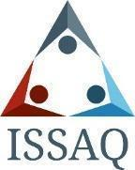
ISSAQ 101: Introduction to ISSAQ and

Noncognitive skills

General Information

Purpose
Review the importance of noncognitive skills in student success. It will also introduce and allow time to complete the ISSAQ Student Survey.

Learning Outcomes
- Students will be able to identify noncognitive skills.
- Students will begin to understand the importance of noncognitive skills in their success.

Course Materials

Required Materials
- Computer/device

Optional Materials
- N/A

References/Resources
- DIA, Higher Education Collaborators

Agenda

Introduction
  - Use this slide deck to introduce the ISSAQ assessment and noncognitive skills.

Activity
  - Complete ISSAQ Assessment

Discussion & Reflection
  - Within the PPT and also will continue next class with the review of their ISSAQ self-assessment results.

Assignment(s)
  - Complete the assessment if unable to complete in class.

